

NAME: JACOB JOSEPH ERISHLO
UNIT: MOBILE APPLICATION DEVELOPMENT
UNIT CODE: BIT4107
PROJECT TITLE: TWONKSACCO MOBILE BANKING APP

This mobile banking application is developed as an academic project for partial fulfillment of the requirements for the unit BIT4107: Mobile Application Development, to be submitted to the lecturer for assessment and academic grading
Installation of Android studio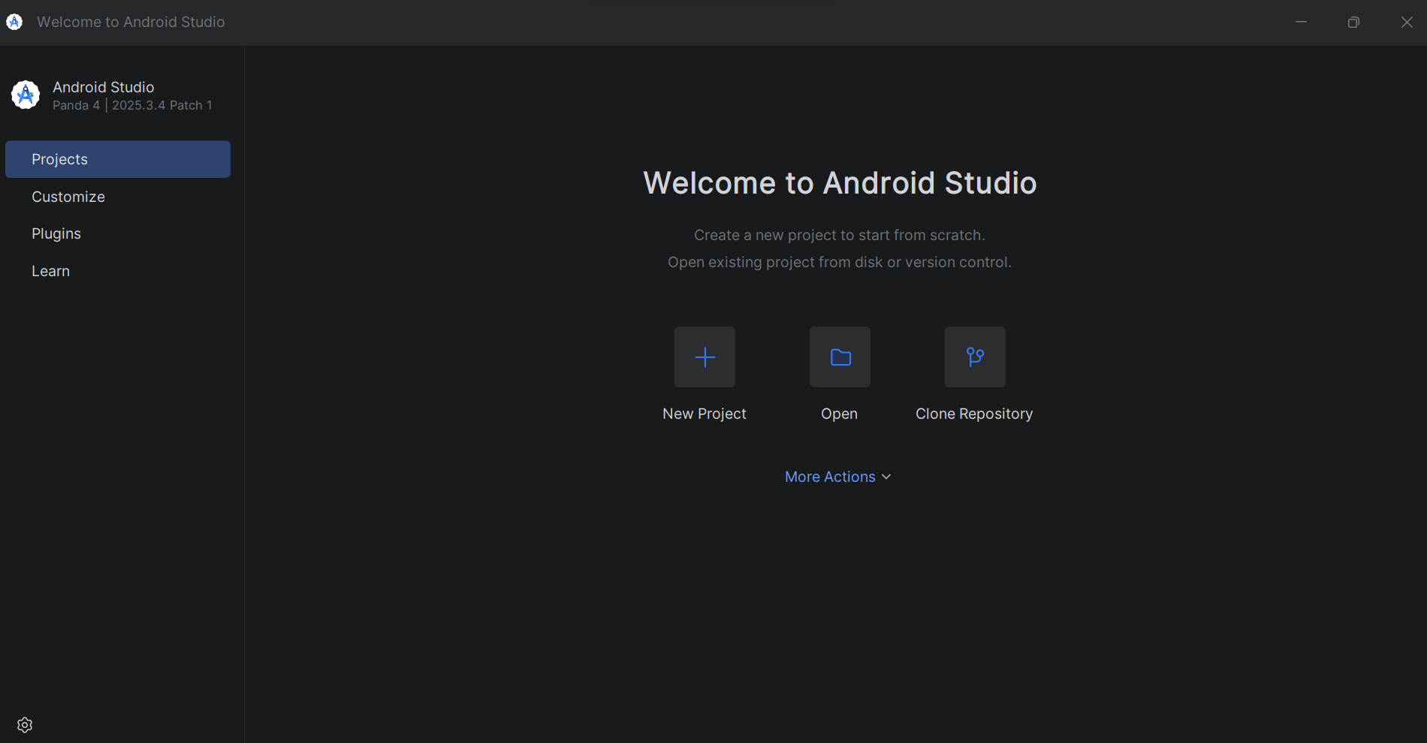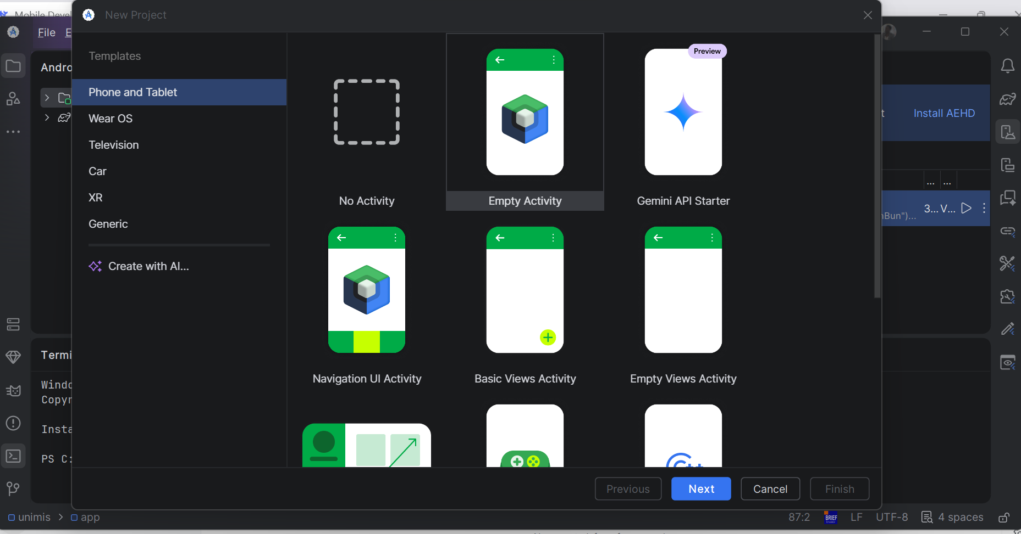

Installation and confirmation of JDK
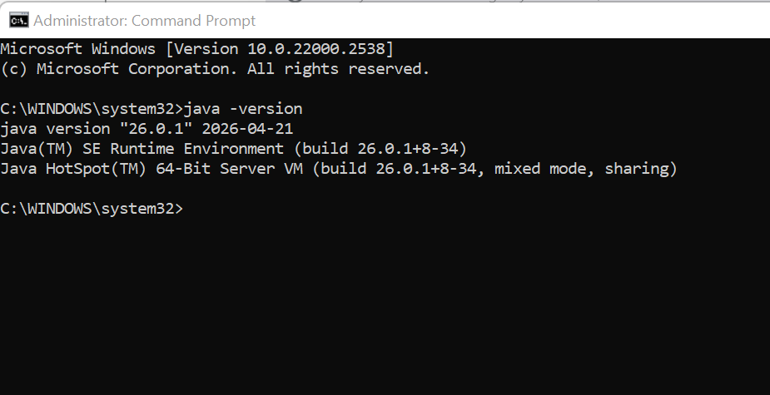

3. Git installation for windows
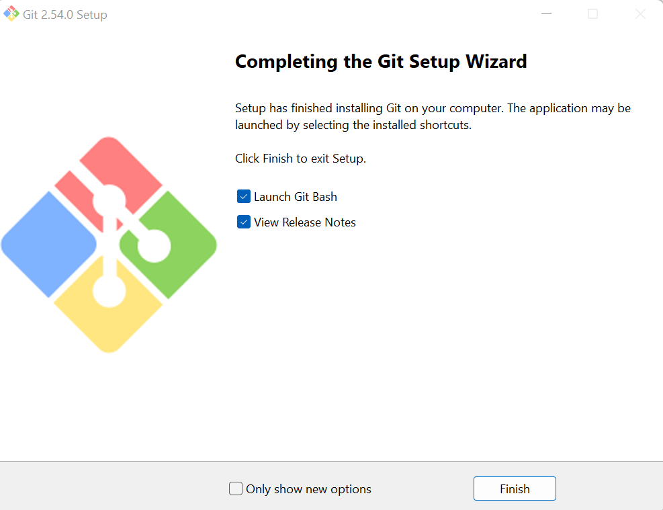

Installation and running of flutter
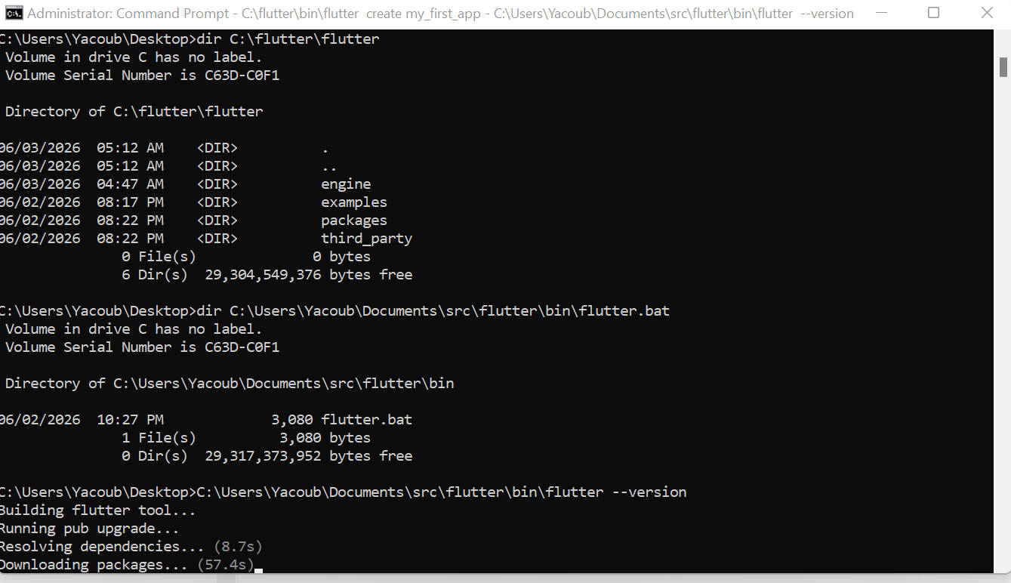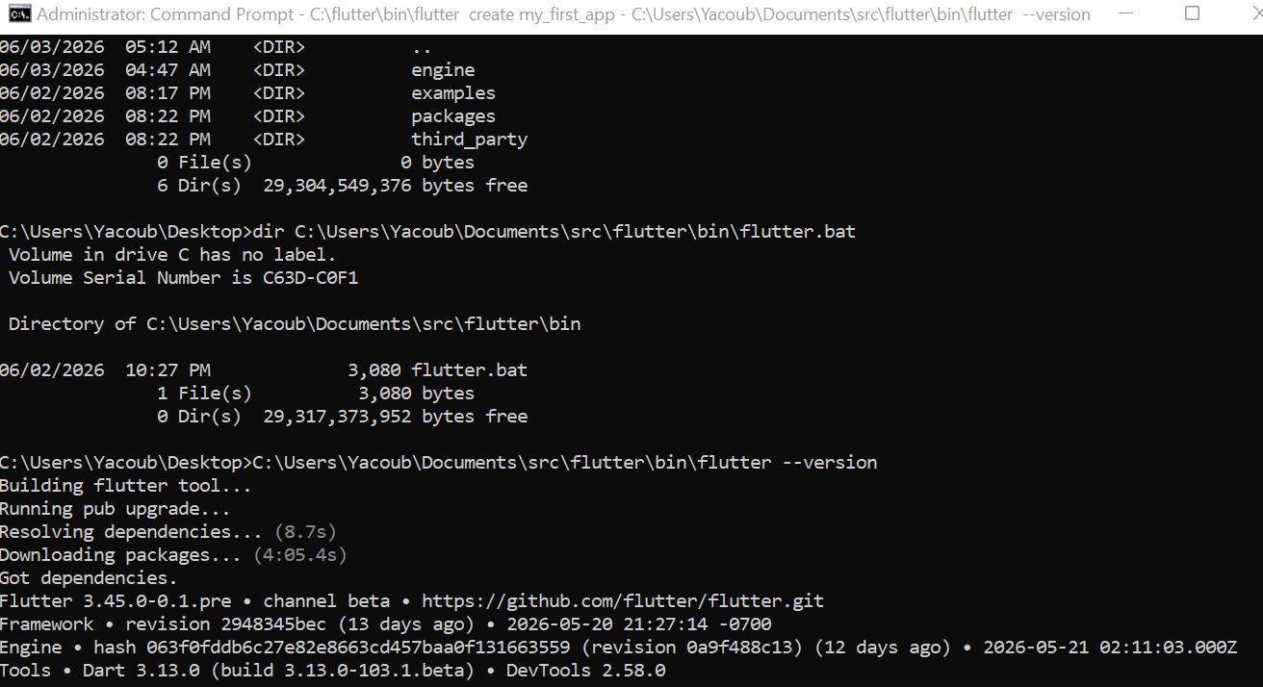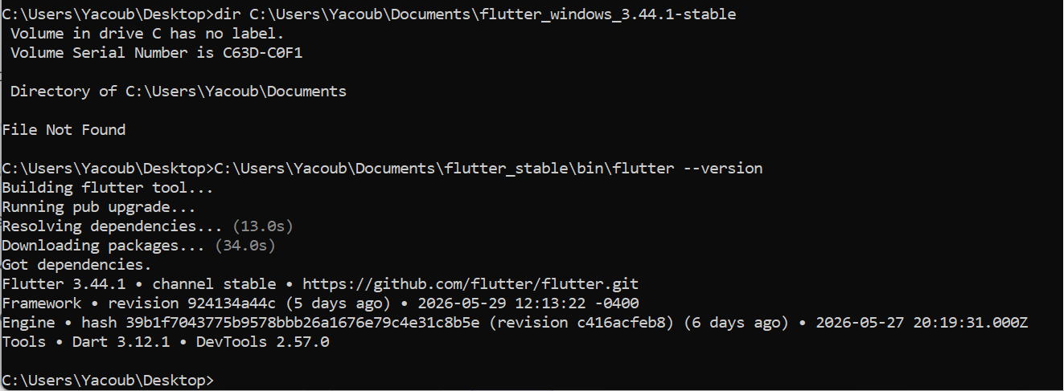
Created a student_manager_app:
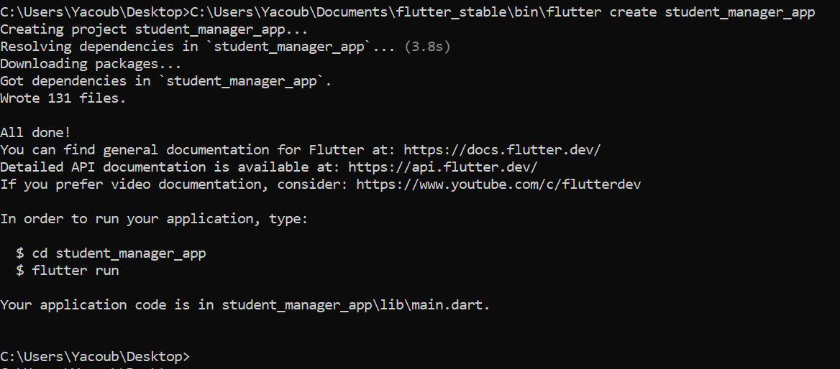
Installation of emulator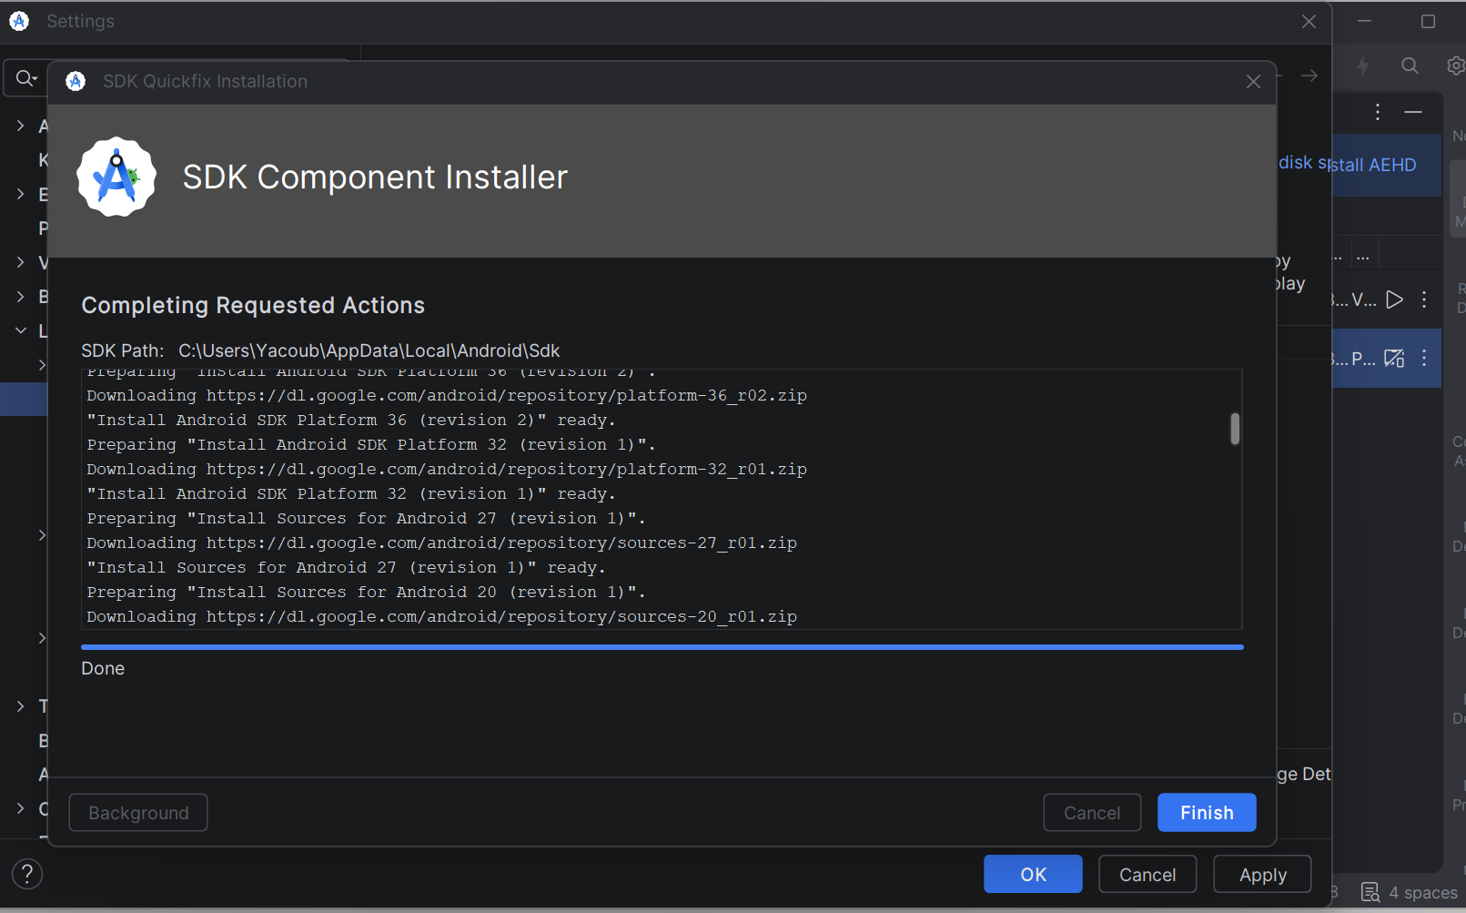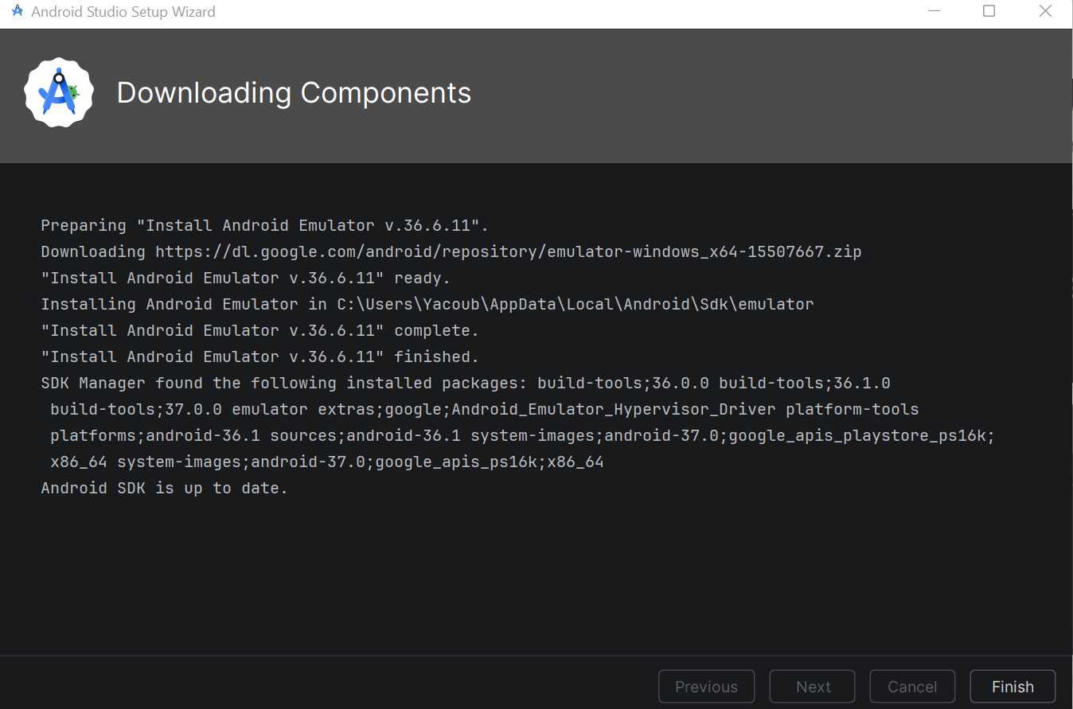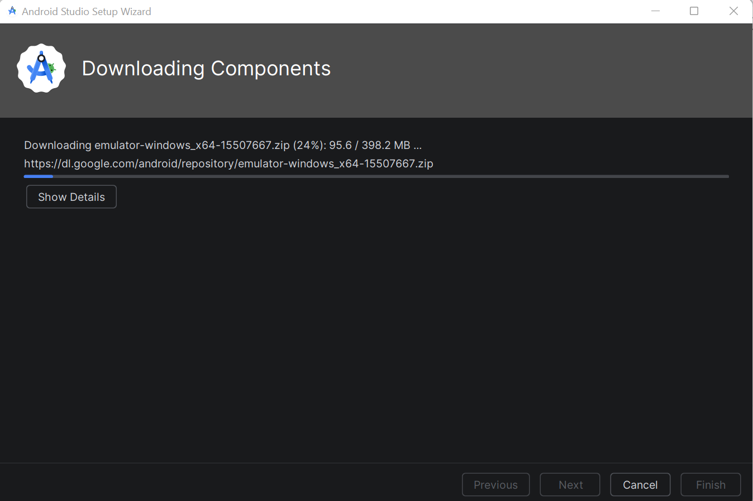

JDK Installed in the PC
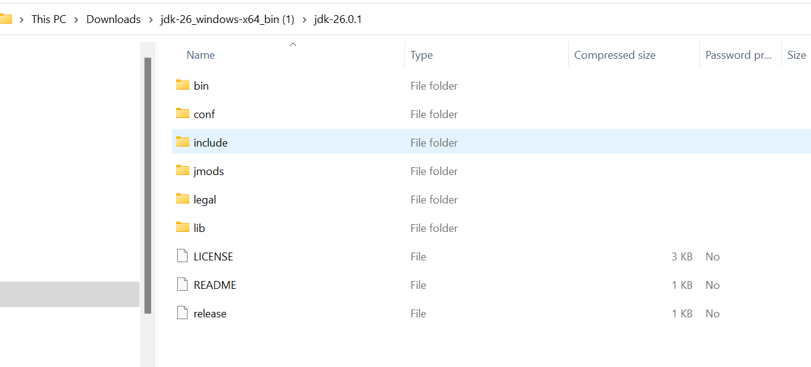
I

Installation of VS Code; 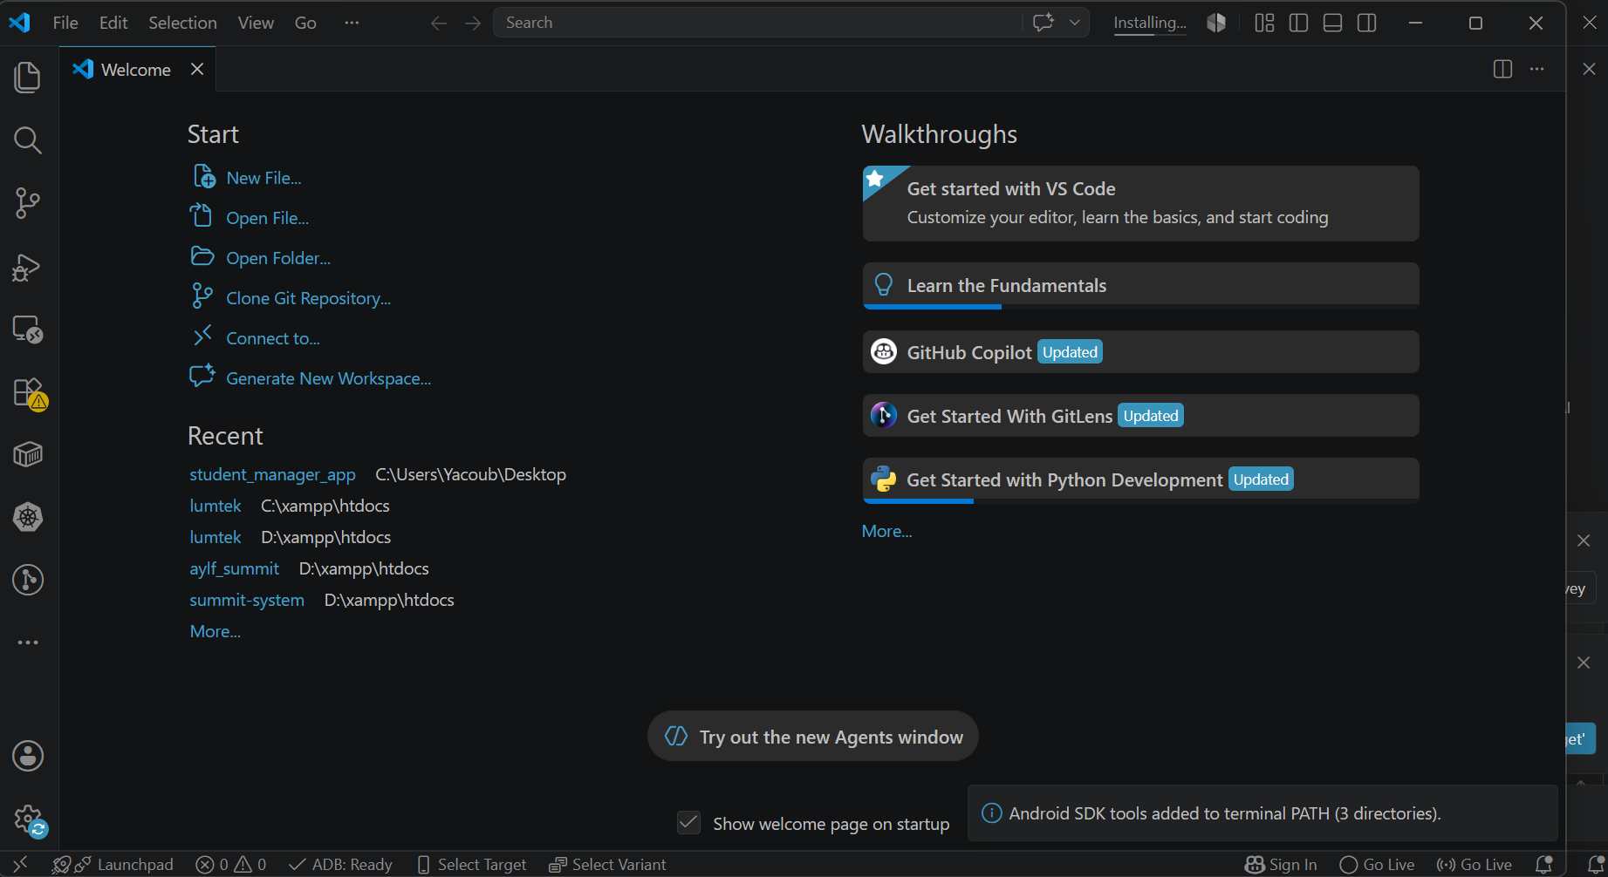

Flutter Installations; 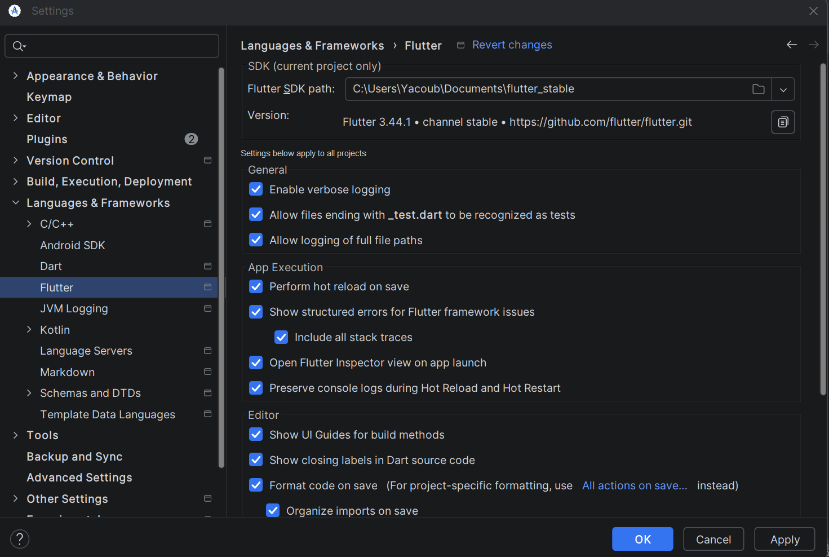

Dart Installation
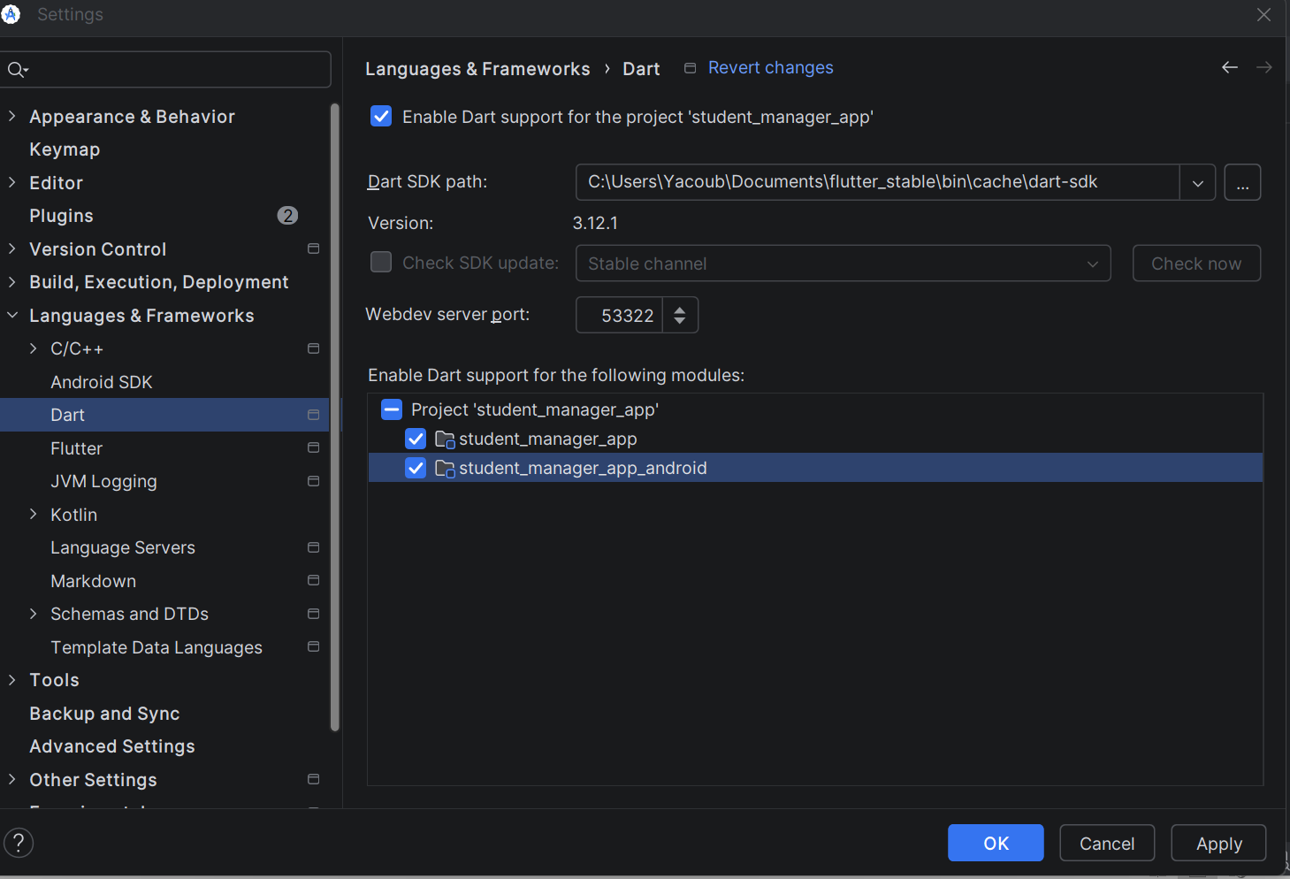

Testing of Flutter workerbility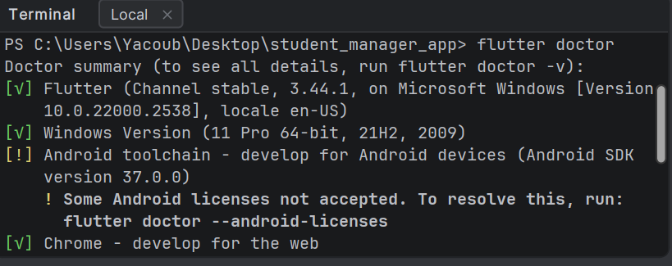

A Simple hello Android Page;

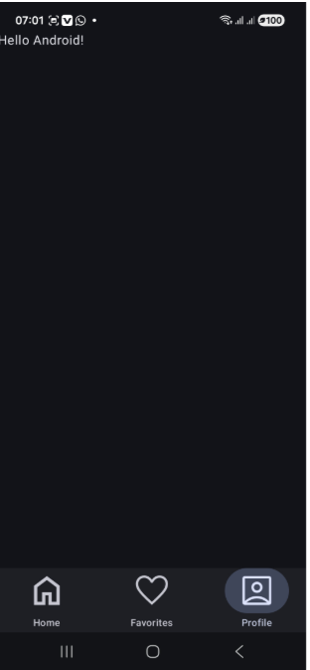

A simple Student management App
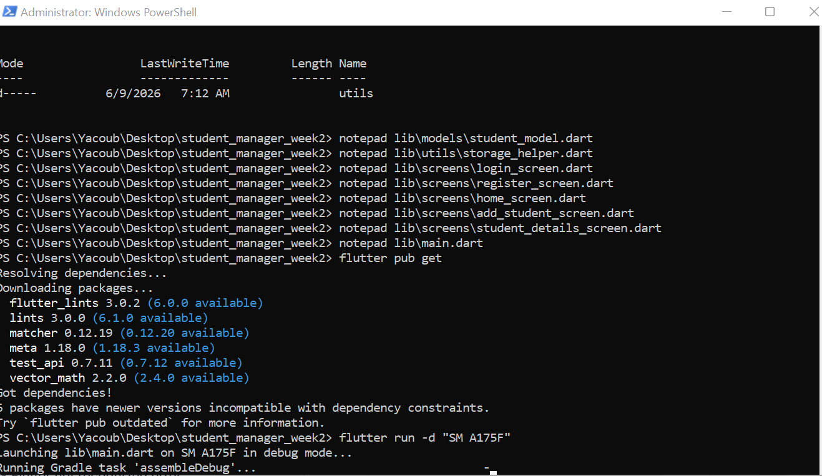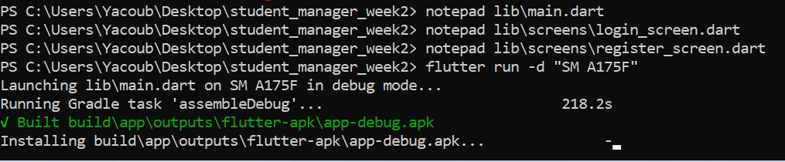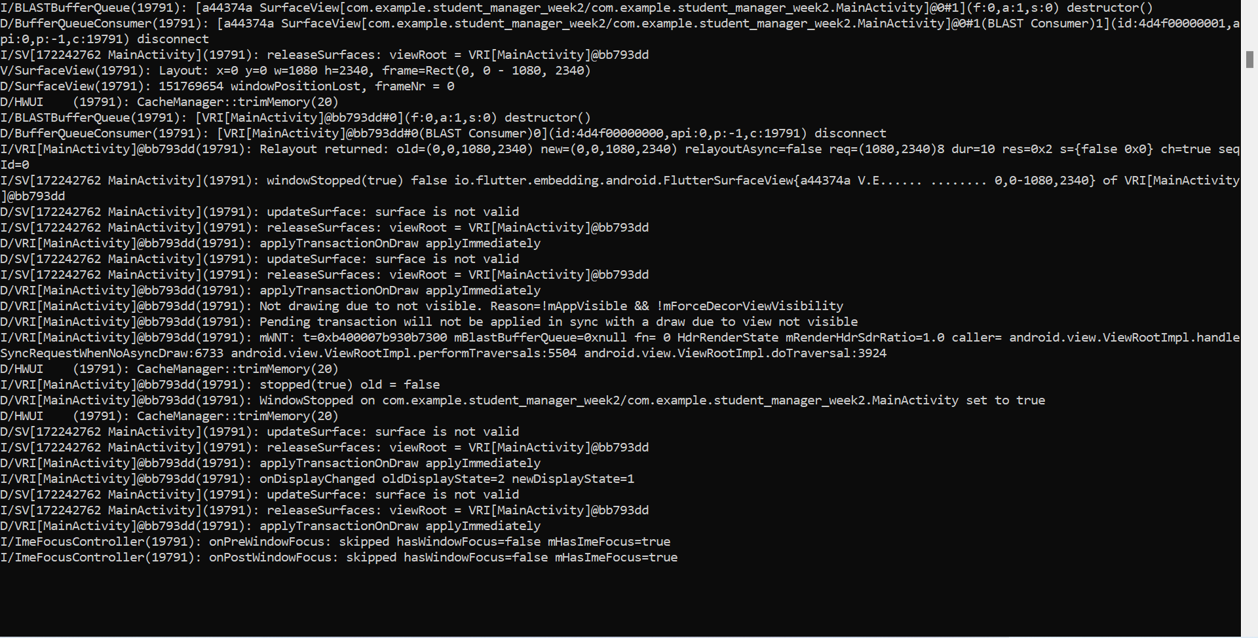
The Student App output (Mobile App screen shots)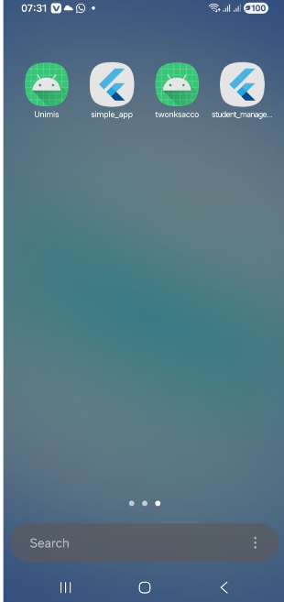 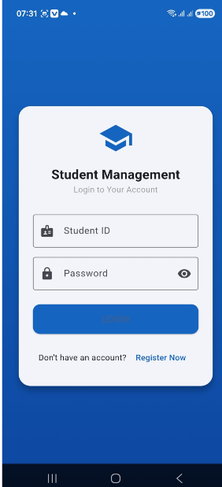 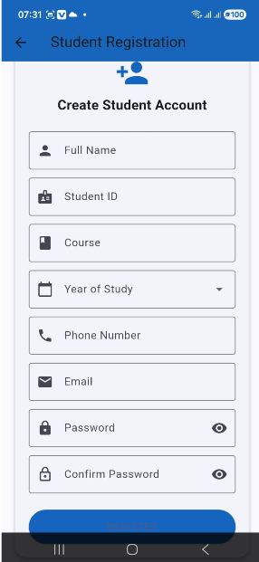 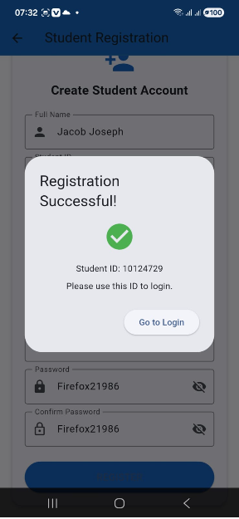 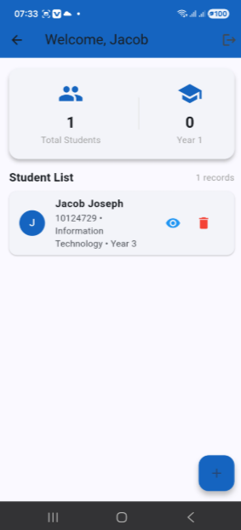 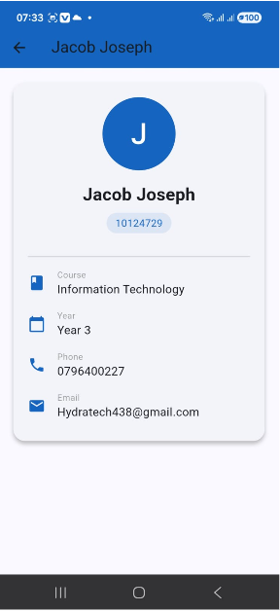 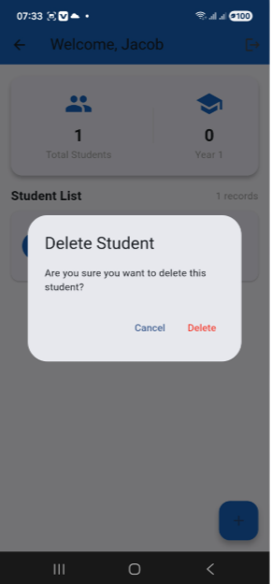
Real world project that I am developing;
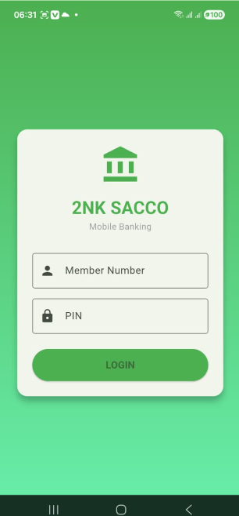
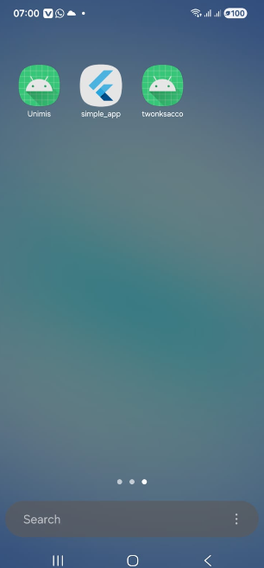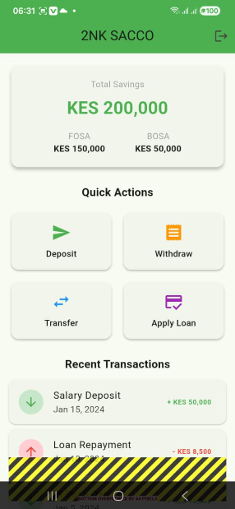

WEEK 1: INTRODUCTION TO MOBILE DEVELOPMENT

Learning Outcomes:
- Installed Android Studio, Flutter SDK, and Git
- Created first Flutter application
- Modified app title, colors, and font sizes
- Ran app on mobile phone

WEEK 2: PROGRAMMING LANGUAGES AND FRAMEWORKS
Student Management App Features:
1. Login Screen with validation
2. Student Registration
3. Add new students
4. View all students
5. Delete students
6. Local storage using SharedPreferences

Code Snippet (Login Screen):
